# Thanksgiving 2014

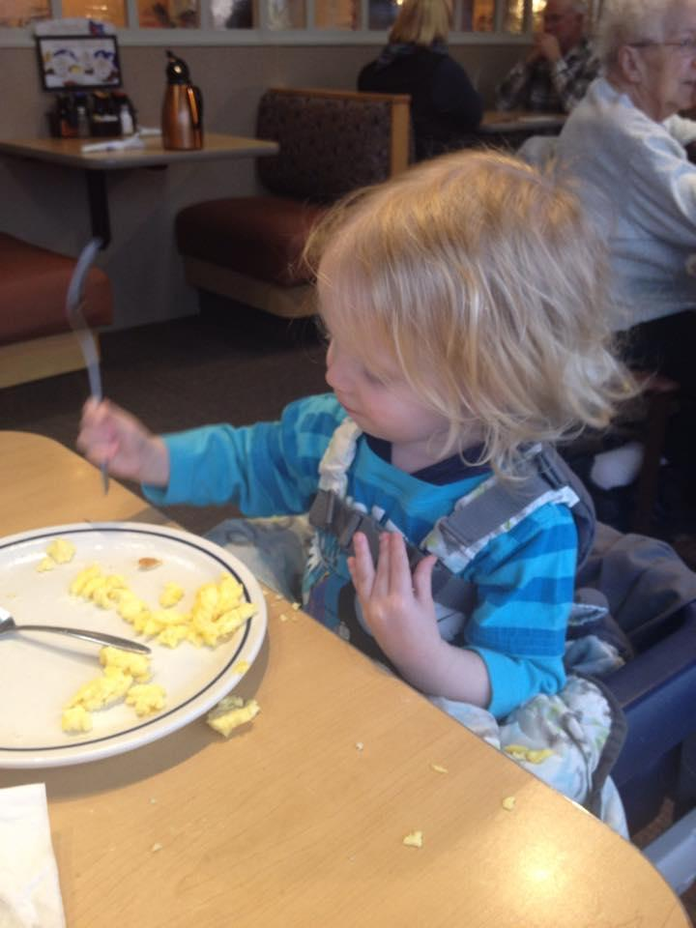

We celebrated Thanksgiving this year with a small meal Wednesday night, and then lunch at IHOP. We weren’t able to travel to see anybody because of Theresa’s work schedule, but it was still nice to have a quiet meal together and to stay around home. This was our first Thanksgiving since buying our new house.

While we were eating at IHOP I told the kids that we had a lot to be thankful for. We drove to the restaurant in two cars, their mother was leaving soon to go to her job, and I was on break from my job. I explained that we should be grateful that we are both steadily employed. We are living in a wonderful house which we own now, and are all relatively healthy. We are also surrounded by a large circle of family and friends who all support us, and whom we all care about in return.

I said that I was especially grateful for all of them.

View Photo Gallery

[Read Online](https://docs.google.com/document/d/1iXJchTH9tf8s_HUjNqIxq-TjJicuPvW-U0xu8eACGiE/pub) / [Share Feedback](https://docs.google.com/document/d/1iXJchTH9tf8s_HUjNqIxq-TjJicuPvW-U0xu8eACGiE/edit?usp=sharing) / [Return to Blog](http://cyberland.github.io/CyberEye/)